Stock Allocations design

Stock Allocations design 1
Motivation 2
Scenarios and Test Cases 3
Solution 3
Future Considerations 5

Motivation

Stock allocations and the existing allocations are identical in terms of propriety schemes, quantity prorating, etc. This allows us to reuse all of the existing strategies. However, the major difference between stock and the existing strategies is in how lot sizes are handled. Stock primarily trades in increments of 100 shares, where as options and futures trade in increments of 1 contract. This quantity is called the lot size. Since options can only trade in whole lots (i.e. you cannot trade a fraction of a contract), there is no support for odd lot allocations. Stock on the other hand can trade in partial lots. The goal of this design is to enhance the existing allocation strategies, and the allocation process a whole, to support allocation of odd lot portions.

Allocating odd lot portions have many rules that must be followed. The following are the constraints that must be obeyed when allocating an odd lot portion. The following definitions and abbreviations will be used
Odd lot (OL) = any share quantity less than 100.
Mixed lot (ML) = any share quantity not evenly divisible by 100.
Odd Lot Portion (OLP) = the quantity of a ML that is not divisible by 100. For brevity we will consider an OL to be an OLP.
Round lot (RL) = a quantity evenly divisible 100
Round lot portion (RLP) = the quantity of a ML that is evenly divisible by 100. For brevity we will consider a RL to be a RLP.

- An order shall never trade and leave just an OLP
- Only an order’s RLP can trade with another order
- An OLP can trade with Quote
- An OLP is sent to manual only when the RLP has entirely traded.
- The quantity of OLPs assigned to a MM in a single trade shall not exceed the quoted quantity.
- A quote shall be decremented by the exact quantity traded, however, the quantity displayed will be the next whole lot. Therefore, a quote can trade at most the quoted quantity in any single trade but up to 99 shares more over multiple trades.
- An OL newly received that is marketable against an order resting in the book will be sent to manual.
- All OLs remaining after a trade that are marketable at the traded price, including those that were OLPs of MLs where the RLP has now traded, shall be sent to manual.

Scenarios and Test Cases
The attached spreadsheet contains the scenarios and test cases. The spreadsheet attempts to layout various possible combinations of orders, quote, mixed lots, odd lots, prices, priorities and order book states. From these are derived as set of test cases.

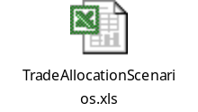

Solution

This solution requires two main pieces and several small ancillary changes. First, create a new TradeServiceStockImpl that will perform the OL and OLP handling. Second, the allocation strategies need to be refactored to acknowledge OLs and OLPs. Finally, minor changes to QuoteSideImpl, Tradable, and OrderBookImpl.

The following class diagram shows the TradeService classes.

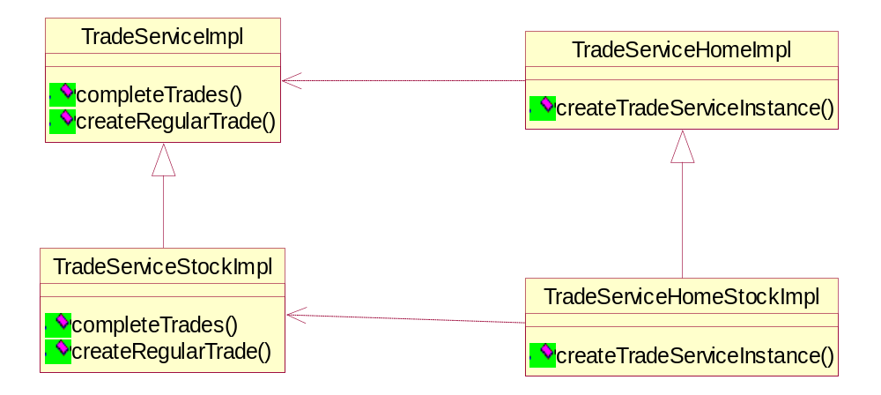

The TradeServiceStockImpl use all of the existing code from trade service. It simply augments that class to handle OLs and OLPs so they can be routed to manual or assigned to a MM as neceassry.

The allocation strategies need a little more work. For these I needed to create an AllocationStrategyOperations strategy class. This handles the allocation operations in a way that can vary by configuration. For stock configurations we will use stock specific operations that ignore OLs and OLPs during allocation and round quantities to the next whole lot when prorating amongst MMs. The following class diagram shows the new AllocationStrategy hierarchy -

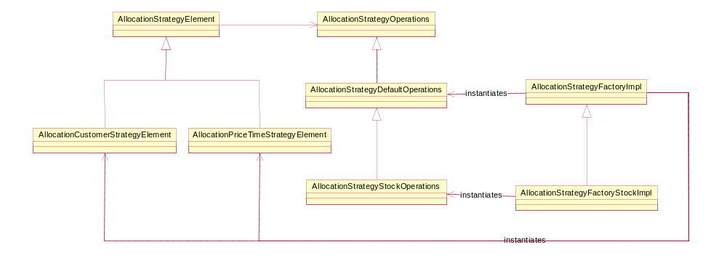

The changes to QuoteSideImpl are to handle the rounding of the quote to the next whole lot. I capitalized on the getQuantityAllowed method to represent the rounded quantity that is allowed to trade where as the getQuantity method will return the quote’s raw quantity for purposes of determining when the quote was traded out.

The OrderBook now has an editor for Stock. This editor is the same for everything except when unbooking. It determines the quantity to unbook from the order book differently for quotes since the quantity traded does not necessarily match the quantity removed from the book.. For example, a quote that has only 50 shares remaining and a lot size of 100 will quote 100. A trade of 50 to 100 shares should unbook 100 shares but a trade of 49 or less should not unbook anything.

Future Considerations

The TradeService has quite a bit of specialized knowledge about the OL routing and allocations. Of course some class(es) must, but should more of this be in the allocation strategies instead? How would that work? I don’t have an alternative design but I wonder at times if the current design is not optimal. Future requirements will probably show if the TradeService having this knowledge is too limiting.

